Introduction
The goal is to create and test machine learning models that accurately classify t-shirt features.
In this report we aimed that using the t-shirts.csv dataset, provide a practical introduction to simple machine learning algorithms and the basic steps of implementing a machine learning project: data mining and problem definition, data preparation, selection of algorithms and hyperparameters, evaluation of algorithms, improvement of results, and presentation of results.

Data – Mining
Using below .info, .describe, .head methods used to present the summary of data, Comprehensive summary (numeric and categoric) and first a few rows of the data, in order to analyze the data before start to proceed in ML.
print(shirt_size.info()) #summary of data
print(shirt_size.describe(include='all'))#comprehensive summary(numeric,categoric)
print(shirt_size.head(10))# first 10 row

Data Preparation
-Encoding categorical variables -
Categorical(String) features converted to numerical data for algortihms to process [0,1 ].
Fit_transform in LabelEncoder library is used to convert this categorical to numerical features.

Split Data
Demand row from the file for x is removed in intention of train the rest of the columns(size, material, color, sleeves) and see the demand results based on the features.
%70 to %30 technique used to train and test to data.
(x_train=used to train the model , y_train=The target values corresponding to X_train)
x_test= used to test the model, y_test= target values corresponding to X_test.

Data Pre-Processing
Normalization and standardization methods are entegrated in intention of increase the efficiency of the classifiers by grouping the train data. By these method we are ensuring that the feature are on same scale and Thus improves the performance of ML.

Normalization
Previously converted from categorical to numerical features are on the same scale. It groups the numerical features on [0,1] for %70 training for generalize unseen data.

Standardization
We are standardized the features 0 and standard deviation of 1 which also another technique to improve the performance of ML.

Naïve-Beyes
The Naive Bayes classifier is a simple and effective probabilistic machine learning algorithm used primarily for classification tasks. It is based on Bayes' Theorem and makes the assumption that the features (predictors) are independent given the class label.
2 different variations of the Naïve Beyes used to see the accuracy result.
MultinominalNB
(used with 3 hyperparameter) fit to train ML on training data
Hyperparameters:
alpha=0.000001 -> avoid zero probabilities,
force_alpha=True,
fit_prior=True
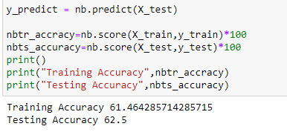
GaussianNB
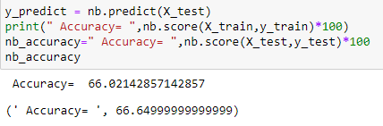
As we can see from the accuracy training and test results, GaussianNB variation is more accurate than MultinominalNB.

Decision_TreeClassifier
Decision tree recursively splits the data based on the most unique.
Hyperparameters ->
max_depth=100, -> prevent overfit minimal cost,
random_state=200,
ccp_alpha=0.00001, -> compexity prunning alpha
criterion='gini' -> measure used in decision trees
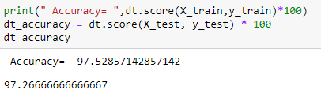

Below Is accuracy result for both NaiveBeyes and Decision trees so far :
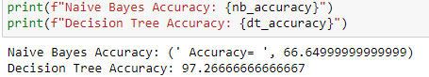

Scaled features for training using most efficient classifier is presented below.
Normalization classification for Decision tree ->
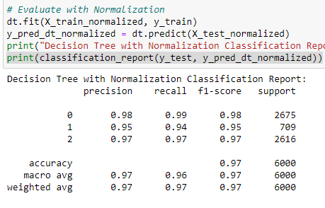

With Standardization ->
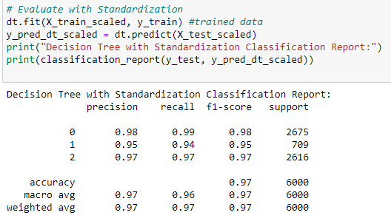
Conclusion
The ML learning project demonstrates the practical implementation of classification algorithms using t-shirts.csv. In general we did data mining, preparation, applying to classification techniques, and evaluating their performance. The Gaussian Naive Bayes classifier performed better than the Multinomial Naive Bayes classifier. Moreover, the Decision Tree classifier's accuracy improved significantly with both normalization and standardization, showing the importance of data pre-processing in machine learning tasks. The results highlight the effectiveness of using different techniques and hyperparameters to enhance the performance of machine learning models.

